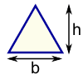 | Triangle  Area = ½ × b × h  b = base  h = vertical height

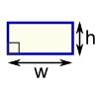 | Rectangle  Area = w × h  w = width  h = height

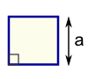 | Square  Area = a²  a = length of side

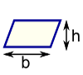 | Parallelogram  Area = b × h  b = base  h = vertical height

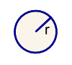 | Circle  Area = π × r²  Circumference = 2 × π × r  r = radius

